**Functions – Notes**

**Find the equation of the curve with equation y = a + k $\sqrt{x+b}$ drawn below:**

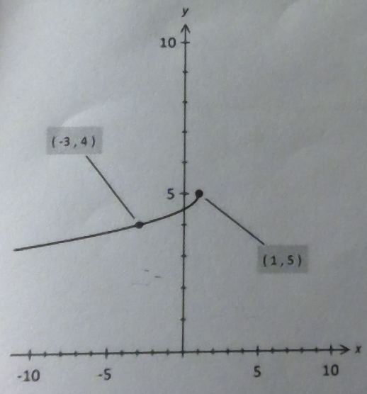

Turning point is (1 , 5) 🡪 y = a + k $\sqrt{x-1}$ + 5

Flipped over the x-axis and y-axis 🡪 y = –k $\sqrt{-(x-1)}$ + 5

Simplify 🡪 y = = –k $\sqrt{-x+1}$ + 5 🡪 y = = –k $\sqrt{1-x}$ + 5

Passes through (–3 , 4) 🡪 Substitute: 4 = –k $\sqrt{-(-3)+1}$ + 5 🡪 4 = –k $\sqrt{4}$ + 5 🡪 k = – $\frac{1}{2}$

**State 2 possible equations for an exponential curve with asymptote y = –2 and vertical intercept (0 , –1).**

Vertical asymptote y = –2 🡪 y = ka-x – 2

Vertical intercept (0 , –1) 🡪 k = 1 🡪 y = a-x – 2 where a > 0

**State 2 possible equations for an exponential curve with asymptote y = 2 and vertical intercept (0 , –3).**

Vertical asymptote y = 2 🡪 y = ka-x + 2

Vertical intercept (0 , –3) 🡪 k = –5 🡪 y = –5ax + 2 where a > 0

**T varies directly with the square root of I and varies inversely with the square root of M. Given that T = 2π when I = 9 and M = 4, find T in terms of I and M.**

T = k $\sqrt{\frac{I}{T}}$ = 2π = k 🡪 360° = 🡪 k = 240° = = 🡪 T = $\frac{4π}{3}\sqrt{\frac{I}{T}}$

**Consider the equation y = f(x) = k(x+2)(x2–3x+c) where k and c are constants. Find the values of k and c if f(–4) = f(–2) = 0 and f(0) = –4.**

k(x+2)(x+4)(x+a) = k(x+2)(x2–3x+c) We use the roots to form an equation.

(x+4)(x+a) = x2–3x+c We cancel the common factor out k(x+2).

x2 + xa + 4x + 4a = x2–3x+c We factorise.

x2 + x(a + 4) + 4a = x2–3x+c We compare the coefficients.

(Comparing coefficients) 🡪

a + 4 = –3

a = –7

–4a = c 🡪 –28 = c We substitute ‘a’ (–7) into when x = 0 in (x+4)(x+a) to find ‘c’.

f(x) = k(x+2)(x2–3x–28) We substitute the value for ‘c’ into the original function.

When y = 0 🡪 –4 = k(–56) We know that one of the roots is (–4 , 0)

k = $\frac{–4}{–56}$ = $\frac{1}{14}$ We use algebra to find the value of ‘k’.

f(x) = (x+2)(x2–3x–28) We form the final function.

f(x) = $\frac{1}{14}$ (x+2)(x–7)(x+4)

**State 2 possible equations for a circle with radius 5 and passing through the point with coordinates (4 , 4).**

Equation 1: (x+1)2 + (y–4)2 = 25

Equation 2: (x–9)2 + (y–4)2 = 25

(4, 4)

(9, 4)

(–1, 4)



**Given that f(x) = x2, solve f(x) = f(2x+1). Describe clearly how you obtained your answer.**

f(x) = x2 🡪 f(2x+1) = (2x+1)2

Hence, f(x) = f(2x+1) becomes x2 = (2x+1)2

x2 = 4x2 + 4x + 1 🡪 x2 = 4x2 + 4x + 1 🡪 3x2 + 4x + 1 = 0 🡪 3x(x+1) + (x+1) = 0 🡪 (3x+1)(x+1) = 0 🡪 x = – $\frac{1}{3}$, –1.